VALUATION REPORT

Mr. Kamal Daulatram Sewda,
Proprietor of M/s. Angel Steel Processing Unit.
At

Land & Building situated at Plot No. C-23/2, MIDC,
Taloja Industrial Area, Village Pendhar, Taloja,
Panvel, Dist. Raigad -410208.

For

STATE BANK OF INDIA – BACKBAY RECLAMATION BRANCH

BY
Manoj Kumar Sharma
Govt. Approved Valuer

Format-A/1

VALUATION REPORT
(For Land & Building)

Name & Address of Branch: State Bank of India – Backbay Reclamation Branch
Name of Customer (s)/ Borrowal unit: Mr. Kamal Daulatram Sewda, Proprietor of M/s. Angel Steel Processing Unit

Ref No.: UCVLLP/SBI/----- Date: 17/09/2025
1. Introduction
a) | Name of the Property Owner  (with address & phone nos.) | Owner:  Add.:  Contact No.:
b) | Purpose of Valuation | For Bank Loan
c) | Date of Inspection of Property
d) | Date of Valuation Report
e) | Name of the Developer of Property (in case of developer built properties)
2. Physical Characteristics of the Property
a) | Location of the Property
 | i. Nearby landmark
 | ii. Postal Address of the Property
 | iii. Area of the plot/land (supported by a plan)
 | iv. Type of Land: Solid, Rocky, Marsh land, reclaimed land, Water-logged, Land locked.
 | v. Independent access/approach to the property etc.
 | vi. Google Map Location of the Property with a neighborhood layout map
 | vii. Details of roads abutting the property
 | viii. Description of adjoining property
 | ix. Plot No. Survey No.
 | x. Ward/Village/Taluka
 | xi. Sub-Registry/Block
 | xii. District
 | xiii Any other aspect
b) | Plinth Area, Carpet Area, and saleable are to be mentioned separately and clarified
c) | Boundaries of the Plot | As per Sale Deed/TIR | Actual
 | East
 | West
 | North
 | South
3. Town Planning parameters
a) | i. Master Plan provisions related to property in terms of land use
 | ii. FAR- Floor Area Rise/FSI- Floor Space Index permitted & consumed
 | iii. Ground coverage
 | iv. Comment on whether OC- Occupancy
 | v. Certificate has been issued or not
 | vi. Comment on unauthorized constructions if any
 | vii. Transferability of developmental rights if any, Building by-laws provision as applicable to the property viz. setbacks, height restriction etc.
 | viii. Planning area/zone
 | ix. Developmental controls
 | x. Zoning regulations
 | xi. Comment on the surrounding land uses and adjoining properties in terms of uses
 | xii. Comment on demolition proceedings if any. Comment on compounding/regularization proceedings
 | xiii. Any other Aspect
4. Document Details and Legal Aspects of Property
a) | Ownership Documents  i. Sale Deed, Gift Deed, Lease Deed  ii. TIR of the Property
b) | Name of the Owner/s
c) | Ordinary status of freehold or leasehold including restrictions on transfer
d) | Agreement of easement if any
e) | Notification of acquisition if any
f) | Special remarks, if any, like threat of acquisition of land for public service purposes, road widening or applicability of CRZ provisions etc. (Distance from sea-coast / tidal level must be incorporated) if any
g) | Heritage restriction, if any
h) | Comment on transferability of the property ownership
i) | Comment on existing mortgages/ charges/encumbrances on the property, if any
j) | Comment on whether the owners of the property have issued any guarantee (personal or corporate) as the case may be
k) | Building plan sanction:  Authority approving the plan -  Name of the office of the Authority -  Any violation from the approved Building Plan -
l) | Whether Property is Agricultural Land if yes, any conversion is contemplated
m) | Whether the property is SARFAESI compliant
n) | a. All legal documents, receipts related to electricity, Water tax, Municipal tax and other building taxes to be verified and copies as applicable to be enclosed with the report.
 | b. Observation on Dispute or Dues if any in payment of bills/taxes to be reported.
o) | Whether entire piece of land on which the unit is set up / property is situated has been mortgaged or to be mortgaged.
p) | Qualification in TIR/mitigation suggested if any.
q) | Any other aspect
5. Economic Aspects of the Property
a) | i. Reasonable letting value
ii. If property is occupied by tenant
‐ Number of tenants
‐ Since how long (tenant- wise)
‐ Status of tenancy right
‐ Rent received per month (tenant-wise) with a comparison of existing market rent
 | iii Taxes and other outings
 | iv. Property Insurance
 | v. Monthly maintenance charges
 | vi. Security charges
 | vii. Any other aspect
6. Socio-cultural Aspects of the Property
a) | Descriptive account of the location of the property in terms of social structure of the area, population, social stratification, regional origin, economic level, location of slums, squatter settlements nearby, etc.
b) | Whether property belongs to social infrastructure like hospital, school, old age homes etc.
7. Functional and Utilitarian Aspects of the Property
a) | Description of the functionality and utility of the property in terms of:
 | i. Space allocation
 | ii. Storage Spaces
 | iii. Utility spaces provided within the building
 | iv. Car Parking facility
 | v. Balconies, etc.
b) | Any other aspect
8. Infrastructure Availability
a) | Description of aqua infrastructure availability in terms of
 | i. Water supply
 | ii. Sewerage/sanitation System Underground or Open
 | iii. Storm water drainage
b) | Description of other physical infrastructure facilities viz.
 | i. Solid waste management
 | ii. Electricity
 | iii. Road and public transport connectivity
 | iv. Availability of other public utilities nearby
c) | Social infrastructure in terms of
 | i. School
 | ii. Medical facilities
 | iii. Recreational facility in terms of parks and open space
9. Marketability of the Property
a) | Marketability of the property in terms of
 | i. Locational attributes
 | ii. Scarcity
 | iii. Demand and supply of the kind of subject property
 | iv. Comparable sale prices in the locality
b) | Any other aspect which has relevance on the value or marketability of the property
10. Engineering and Technology Aspects of the Property
a) | Type of construction
b) | Material & technology used
c) | Specifications,
d) | Maintenance issues
e) | Age of the building
f) | Total life of the building
g) | Extent of deterioration,
h) | Structural safety
i) | Protection against natural disaster viz. earthquakes,
j) | Visible damage in the building
k) | System of air-conditioning
l) | Provision of firefighting
m) | Copies of the plan and elevation of the building to be included
11. Environmental Factors
a) | Use of environment friendly building materials, Green Building techniques if any
b) | Provision of rain water harvesting
c) | Use of solar heating and lightening systems, etc.,
d) | Presence of environmental pollution in the vicinity of the property in terms of industry, heavy traffic etc.
12. Architectural and aesthetic quality of the Property
a) | Descriptive account on whether the building is modern, old fashioned, plain looking or decorative, heritage value,  presence of landscape elements etc.
13. Valuation
a) | Methodology of valuation – Procedures adopted for arriving at the valuation. Valuers may consider various approaches and state explicitly the reason for adopting particular approach and assumptions made, basis adopted with supporting data, comparable sales, and reconciliation of various factors on which final value judgment is arrived at.
b) | Prevailing Market Rate/Price trend of the Property in the locality/city from property search sites viz magickbricks.com, 99acres.com, makaan.com etc. if available
c) | Guideline Rate obtained from Registrar’s office/State Govt. Gazette/ Income Tax Notification
d) | Summary of Valuation
i. Guideline Value
Land:
Building:
 | ii. Fair Market Value
 | iii. Realizable Value
 | iv. Forced/ Distress Sale value.
e) | i. In case of variation of 20% or more in the valuation proposed by the valuer and the Guideline value provided in the State Govt. notification or Income Tax Gazette justification on variation has to be given.  ii. Details of last two transactions in the locality/area to be provided, if available. | The Ready Reckoner Rates are guide line rates of a locality determined by the state Government used for Stamp duties. However, the market value determined by the market forces such as supply & demand, Also Specifications & other amenities Provided for the Property. We have Considered the factors which Elevates the value of the property. It is well located & Easy reaches both rail & road. Keeping in view of good marketability & confirming with agents & instances attached, we gave given the Fair Market value as Mentioned below.
14. Declaration
I hereby declare that:
i. The information provided is true and correct to the best of my knowledge and belief.
ii. The analysis and conclusions are limited by the reported assumptions and conditions.
iii. I have read the Handbook on Policy, Standard and Procedures for Real Estate Valuation by Banks and HFIs in India, 2011, issued by IBA and NHB, fully understood the provisions of the same and followed the provisions of the same to the best of my ability and this report is in conformity to the Standards of Reporting enshrined in the above Handbook.
iv. I have no direct or indirect interest in the above property valued.
v. I/ my authorized representative by the name of Mr. Sanjay Waratkar has inspected the subject property on 16/09/2025.
vi. I am a registered Valuer under Section 34AB of Wealth Tax Act, 1957, Category-Land & Building ( A) for valuing property up to No Limit
vii. I am/am not an approved Valuer under SARFAESI ACT-2002 and am approved by the Bank.
viii. I have not been depanelled or removed from any Bank/Financial Institution/Government Organization at any point of time in the past.
ix. I have submitted the Valuation Report (s) directly to the Bank.
Name and address of the Valuer :
Name :- Manoj Kumar Sharma Address:- Office No. 203, 2nd Floor,
Panel Valuer of State Bank of India Ashar 16 Belleza, Road No 16,
(CCIT/THN/CAT-I/52/2014-2015) Wagle Estate, Thane (W)-400602.

Manoj Kumar Sharma
B.E (Civil), F.I.V., M.I.E
Govt. Regd. Valuer
Panel Valuer of State Bank of India
(IBBI/RV/07/2019/11044)
Date : 17/09/2025
Place: Thane
Mobile No.: 9833198383 / 8108927255
Email: ucvllp@gmail.com / mkssharma1975@gmail.com
15. Enclosures
a) | Layout plan sketch of the area in which the property is located with latitude and longitude
b) | Building Plan
c) | Floor Plan
d) | Photograph of the property (including geo-stamping with date) and owner (in case of housing loans, if borrower is available) including a “Selfie’ of the Valuer at the site
e) | Certified copy of the approved / sanctioned plan wherever applicable from the concerned office
f) | Google Map location of the property and Longitude/Latitude and co-ordinates of the property
g) | Price trend of the Property in the locality/city from property search sites viz Magickbricks.com, 99Acres.com, Makan.com etc
h) | Guideline rate mentioned in the valuation report must be supported by documentary evidence i.e. latest guideline rate published in district website, Registrar Office etc should be printed and signed by the concerned valuer as an evidence of authenticity
i) | Any other relevant documents/ extracts

Marketability

Rate Analysis for Land:

- Land Area Calculation

- Structure

- External Development (security cabin, compound wall, pavement, gate, Lighting, Sewer etc.) (L.S) = Rs. 6,00,00,000/-

Total Value A + B + C = Rs. 33,32,34,700/-

Say Total Value = Rs. 33,32,35,000/- (In word – Rupees Thirty Three crore Thirty two lakh Thirty Five thousand Only)

Remark:
- We have finalized the report on the basis of site visit and copy of: Deed of assignment, Index II, O.C. & Order for transfer of lease etc. However, we have not been provided with approved plan, Title search etc. for verification purpose.
- Property is inspected as shown by person met on site Mr. Kamal Sewda - Owner.
- Toilet units are constructed within the unit.
- The subjected Property is in running condition used as a Steel Manufacturing & Processing.
- Property is situated in MIDC Taloja Industrial area.
- Name of company such as a Alphonso Steel Pvt Ltd displayed at main entrance of the company
- Angel Steel Industries is one of the leading Manufacturers, Exporter & Supplier of Stainless Steel, Carbon Steel, Alloy Steel, Copper, Brass, Lead, Aluminium, Monel, Inconel, Hastalloy, as per standards Lead in form of: Pipes & Tubes in Seamless and Welded in all Grades Buttwelded Pipe Fittings, Forged Fittings & Hydraulic Fittings
- We consider the area given in the Deed of assignment declared by the party and submitted for registration with the government authorities as final for valuation. Any area that is not stated in the Deed of assignment is not considered for valuation unless the area is measured by us in which case that may be considered for valuation purpose.
- The scope of our valuation work is only for banks financial/loan purpose. Further, please be noted that this report shall not be used for any litigation purpose.
- Encumbrance of Loan, Government and other dues, stamp duty, registration charges, transfer charges etc, if any are not considered in the valuation. We assumed that the assets are free from encumbrance unless otherwise stated to us by the party in writing.
- The value given in our report is the estimate of the Fair Market value of the property as on date, considering various aspects of the property as mentioned above.
- The value given in the report is the estimate of the Fair Market value of the property as on date, considering various aspects of the property like amenities in projects, locational advantages, demand and supply equation, interior designing done in the property, outside view, Vashtu aspects etc. considering all the above aspects the rate is considered almost 3 times the ready recknor rate.

Valuation: Here, the approved valuer should discuss in details his approach Market Approach, Income Approach and Cost Approach) to valuation of property and indicate how the value has been arrived at, supported by necessary calculation. Also, such aspects as impending threat of acquisition by government for road widening/ public service purposes, sub merging & applicability of CRZ provisions (Distance from sea-coast / tidal level must be incorporated) and their effect on i) Saleability ii) Likely rental value in future & iii) any likely income it may generated may be discussed)- Approach: Land & Building and Market Approach.
As a result of my appraisal & analysis, it is my considered opinion that the present market value of the above property in the prevailing condition with aforesaid specifications is Rs. 33,32,35,000/- (In word – Rupees Thirty Three crore Thirty two lakh Thirty Five thousand Only)

The Realizable value (90% of Fair Market Value) Rs. 29,99,11,500/- (In Words- Rupees Twenty Nine crore Ninety Nine lakh Eleven thousand five hundred Only)

The Distress value (80% of Fair Market Value) Rs. 26,65,88,000/- (In Words- Rupees Twenty Six crore Sixty Five lakh Eighty Eight thousand Only)

The Government Guideline Value of land Rs. 3,18,04,870/- (In Words- Rupees Three crore eighteen lakh four thousand eight hundred seventy Only)

The Insurance value is Rs. 5,19,45,700/- (In Words- Rupees Five crore ninteen lakh forty five thousand seven hundred Only)
The book value of the above property as of 31/01/2017 is Rs. 4,50,00,000/- (Rupees Four Crore Fifty Lakhs only).

Manoj Kumar Sharma
B.E (Civil), F.I.V., M.I.E
Govt. Regd. Valuer
Panel Valuer of State Bank of India
(IBBI/RV/07/2019/11044)
Date: 17/09/2025
Place: Thane

The undersigned has inspected the property detailed in the valuation Report dated 17/09/2025. We are satisfied that the fair and reasonable market value of the property. Rs. 33,32,35,000/- (In word – Rupees Thirty Three crore Thirty two lakh Thirty Five thousand Only)
Encl:
1. Declaration-cum-undertaking from the valuer (Annexure-III)
2. Model code of conduct for valuer (Annexure-XIV)
(Annexure-III)
DECLARATION- CUM- UNDERTAKING
I, Mr. Manoj Kumar Sharma son of Mr. Satyanarayan Sharma do hereby solemnly affirm and state that
  - I am a citizen of India.
  - I will not undertake valuation of any assets in which I have a direct or indirect interest or become so interested at any time during a period of three years prior to my appointment as valuer or three years after the valuation of assets was conducted by me.
  - The information furnished in my valuation report date 17/09/2025 is true and correct to the best of my knowledge and belief and I have made an impartial and true valuation of the property.

Our representative Mr. Sanjay Waratkar has inspected the property on 16/09/2025
  - Valuation report is submitted in the format as prescribed by the Bank.
  - I have not been decanalled/ delisted by any other bank and in case any such empanelment by other banks during my empanelment with you, I will inform you within 3 days of such depanelment.
  - I have not been removed/dismissed from service/employment earlier
  - I have not been convicted of any offence and sentenced to a term of imprisonment
  - I have not been found guilty of misconduct in professional capacity
  - I have not been declared to be unsound mind
  - I am not an undischarged bankrupt, or has not applied to be adjudicated as bankrupt;
  - I am not an undischarged insolvent.
- I have not been levied a penalty under section 271J of Income-tax Act, 1961 (43 of 1961) and time limit for filing appeal before Commissioner of Income tax (Appeals) or Income-tax Appellate Tribunal, as the case may be has expired, or such penalty has been confirmed by Income-tax Appellate Tribunal, and five years have not elapsed after levy of such penalty.
- I have not been convicted of an offence connected with any proceeding under the Income Tax Act 1961, Wealth Tax Act 1957 or Gift Tax Act 1958.
- My PAN Card number / GST number as applicable is ATMPS1523K / 27AAFFU2364L2ZS.
- I undertake to keep you informed of any events or happenings which would make me ineligible for empanelment as a valuer.
- I have not concealed or suppressed any material information, facts and records and I have made a complete and full disclosure
- I have read the Handbook on Policy, Standards and procedure for Real Estate Valuation, 2011 of the IBA and this report is in conformity to the “Standards” enshrined for valuation in the Part-B of the above handbook to the best of my ability. I have read the International Valuation Standards (IVS) and the report submitted to the Bank for the respective asset class is in conformity to the “Standards” as enshrined for valuation in the IVS in “General Standards” and “Asset Standards” as applicable.
- I abide by the Model Code of Conduct for empanelment of valuer in the Bank. (Annexure V- A) signed copy of same to be taken and kept along with this declaration) t. I am registered under Section 34 AB of the Wealth Tax Act, 1957.
- I am valuer registered with Insolvency & Bankruptcy Board of India (IBBI).
- My CIBIL Score and credit worthiness is as per Bank’s guidelines.
- I am the proprietor authorized official of the firm, who is competent to sign this valuation report.
- I will undertake the valuation work on receipt of Letter of Engagement generated from the system (i.e. LLMS/LOS) only.
- Further, I hereby provide the following information.
- If this format if found changed than it is done as per the requirement of the respective branches. If nothing is heard within 15 days from the date of this report then it is presumed that the valuation report is accepted by the bank in toto. To accept or reject our valuation report is sole discretion of the Bank as well the quantum of loan amount disbursement to your customers on the basis of our valuation will be decided by the bank and we are not held responsible for any changes in the market rates in the future, including becoming NPAs of any properties due to any reason whatsoever.
- Whilst we have taken the opportunity of looking through the documents (whatever available) it is recommended that the relevant documents are subjected to formal legal inspection in order to ensure that there are no elements, restriction or charge contained which are likely to have detrimental effect upon the valuation provided.
Sr.No. | Particulars | Valuer comment
1 | background information of the asset being valued;
2 | purpose of valuation and appointing authority
3 | identity of the valuer and any other experts involved in the valuation;
4 | disclosure of valuer interest or conflict, if any;
5 | date of appointment, valuation date and date of report;
6 | inspections and/or investigations undertaken;
7 | nature and sources of the information used or relied upon;
8 | procedures adopted in carrying out the valuation and  valuation standards followed;
9 | restrictions on use of the report, if any;
10 | major factors that were taken into account during the valuation;
11 | major factors that were not taken into account during valuation;
12 | Caveats, limitations and disclaimers to the extent they explain or elucidate the limitations faced by valuer, which shall not be for the purpose of limiting his responsibility for the valuation report.
Date: 17/09/2025
Place: Thane

Manoj Kumar Sharma
B.E (Civil), F.I.V., M.I.E
Govt. Regd. Valuer
Panel Valuer of State Bank of India
(IBBI/RV/07/2019/11044)
(Annexure-XIV)
MODEL CODE OF CONDUCT FOR VALUERS

Integrity and Fairness
1. A valuer shall, in the conduct of his/its business, follow high standards of integrity and fairness in all his/its dealings with his/its clients and other valuers.

2. A valuer shall maintain integrity by being honest, straightforward, and forthright in all professional relationships.

3. A valuer shall endeavour to ensure that he/it provides true and adequate information and shall not misrepresent any facts or situations.

4. A valuer shall refrain from being involved in any action that would bring disrepute to the profession.

5. A valuer shall keep public interest foremost while delivering his services.

Professional Competence and Due Care
6. A valuer shall render at all times high standards of service, exercise due diligence, ensure proper care and exercise independent professional judgment.

7. A valuer shall carry out professional services in accordance with the relevant technical and professional standards that may be specified from time to time.

8. A valuer shall continuously maintain professional knowledge and skill to provide competent professional service based on up-to-date developments in practice, prevailing regulations/guidelines and techniques.

9. In the preparation of a valuation report, the valuer shall not disclaim liability for his/its expertise or deny his/its duty of care, except to the extent that the assumptions are based on statements of fact provided by the company or its auditors or consultants or information available in public domain and not generated by the valuer.

10. A valuer shall not carry out any instruction of the client insofar as they are incompatible with the requirements of integrity, objectivity and independence.

11. A valuer shall clearly state to his client the services that he would be competent to provide and the services for which he would be relying on other valuers or professionals or for which the client can have a separate arrangement with other valuers.

Independence and Disclosure of Interest
12. A valuer shall act with objectivity in his/its professional dealings by ensuring that his/its decisions are made without the presence of any bias, conflict of interest, coercion, or undue influence of any party, whether directly connected to the valuation assignment or not.

13. A valuer shall not take up an assignment if he/it or any of his/its relatives or associates is not independent in terms of association to the company.

14. A valuer shall maintain complete independence in his/its professional relationships and shall conduct the valuation independent of external influences.

15. A valuer shall wherever necessary disclose to the clients, possible sources of conflicts of duties and interests, while providing unbiased services.

16. A valuer shall not deal in securities of any subject company after any time when he/it first becomes aware of the possibility of his/its association with the valuation, and in accordance with the Securities and Exchange Board of India (Prohibition of Insider Trading) Regulations, 2015 or till the time the valuation report becomes public, whichever is earlier.

17. A valuer shall not indulge in “mandate snatching” or offering “convenience valuations” in order to cater to a company or client’s needs.

18. As an independent valuer, the valuer shall not charge success fee.

19. In any fairness opinion or independent expert opinion submitted by a valuer, if there has been a prior engagement in an unconnected transaction, the valuer shall declare the association with the company during the last five years.

Confidentiality
20. A valuer shall not use or divulge to other clients or any other party any confidential information about the subject company, which has come to his/its knowledge without proper and specific authority or unless there is a legal or professional right or duty to disclose.

Information Management
21. A valuer shall ensure that he/ it maintains written contemporaneous records for any decision taken, the reasons for taking the decision, and the information and evidence in support of such decision. This shall be maintained so as to sufficiently enable a reasonable person to take a view on the appropriateness of his/its decisions and actions.

22. A valuer shall appear, co-operate and be available for inspections and investigations carried out by the authority, any person authorised by the authority, the registered valuers organisation with which he/it is registered or any other statutory regulatory body.

23. A valuer shall provide all information and records as may be required by the authority, the Tribunal, Appellate Tribunal, the registered valuers organisation with which he/it is registered, or any other statutory regulatory body.

24. A valuer while respecting the confidentiality of information acquired during the course of performing professional services, shall maintain proper working papers for a period of three years or such longer period as required in its contract for a specific valuation, for production before a regulatory authority or for a peer review. In the event of a pending case before the Tribunal or Appellate Tribunal, the record shall be maintained till the disposal of the case.

Gifts and hospitality.
25. A valuer or his/its relative shall not accept gifts or hospitality which undermines or affects his independence as a valuer.
Explanation.─ For the purposes of this code the term ‘relative’ shall have the same meaning as defined in clause (77) of Section 2 of the Companies Act, 2013 (18 of 2013).

26. A valuer shall not offer gifts or hospitality or a financial or any other advantage to a public servant or any other person with a view to obtain or retain work for himself/ itself, or to obtain or retain an advantage in the conduct of profession for himself/ itself.

Remuneration and Costs.
27. A valuer shall provide services for remuneration which is charged in a transparent manner, is a reasonable reflection of the work necessarily and properly undertaken, and is not inconsistent with the applicable rules.

28. A valuer shall not accept any fees or charges other than those which are disclosed in a written contract with the person to whom he would be rendering service.

Occupation, employability and restrictions.
29. A valuer shall refrain from accepting too many assignments, if he/it is unlikely to be able to devote adequate time to each of his/ its assignments.

30. A valuer shall not conduct business which in the opinion of the authority or the registered valuer organisation discredits the profession.

Miscellaneous
31. A valuer shall refrain from undertaking to review the work of another valuer of the same client except under written orders from the bank or housing finance institutions and with knowledge of the concerned valuer.

32. A valuer shall follow this code as amended or revised from time to time.

Date: 17/09/2025
Place: Thane
Manoj Kumar Sharma
B.E (Civil), F.I.V., M.I.E
Govt. Regd. Valuer
Panel Valuer of State Bank of India
(IBBI/RV/07/2019/11044)

GOOGLE MAP:

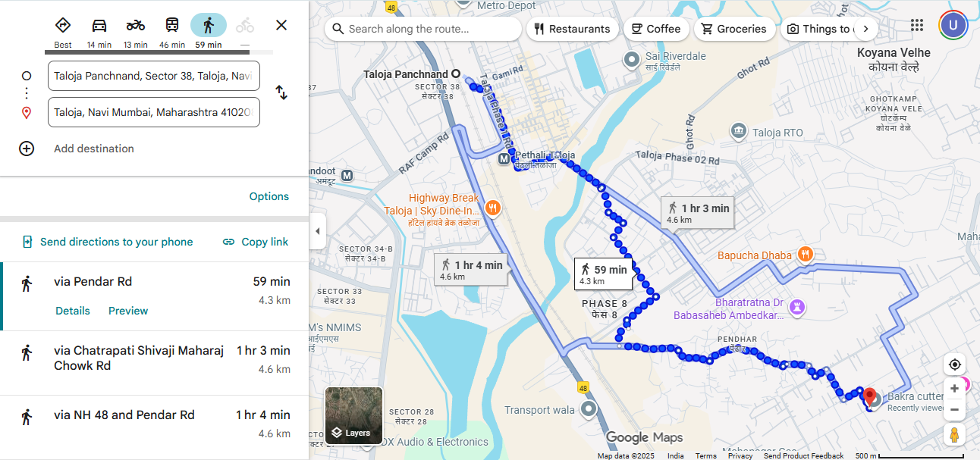

SATELITE VIEW:
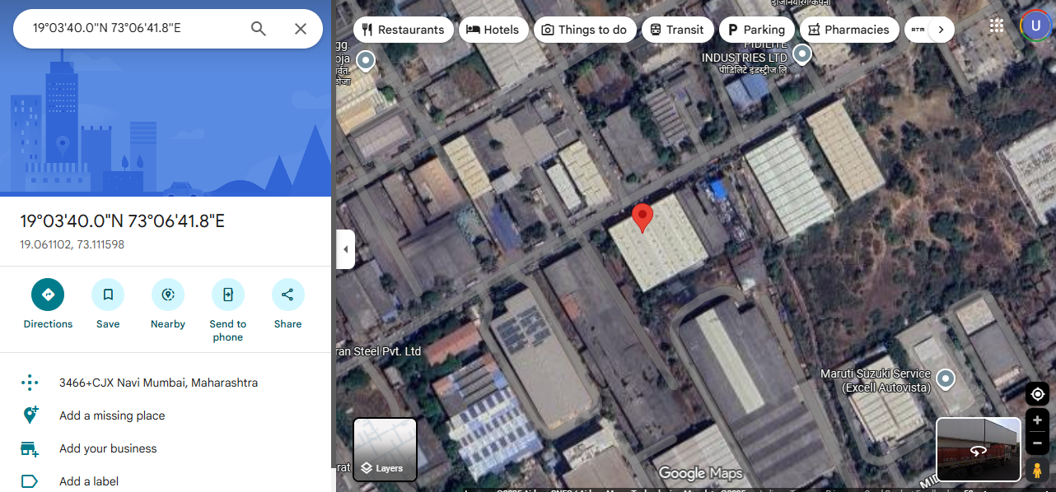

GOVT. READY RECKNOR RATE

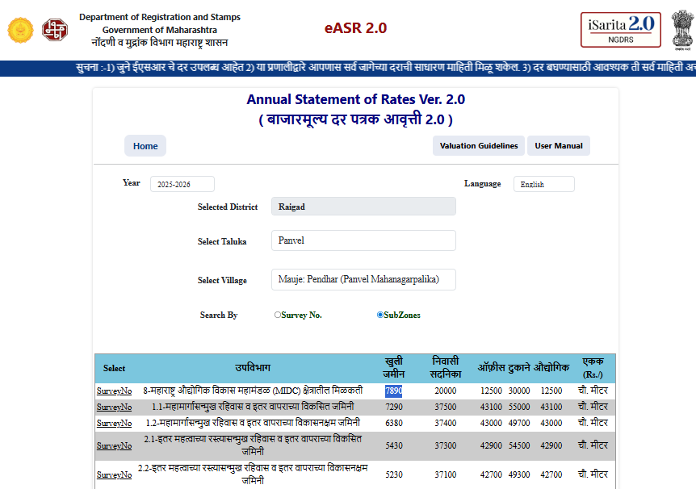

SALE EVIDENCE:
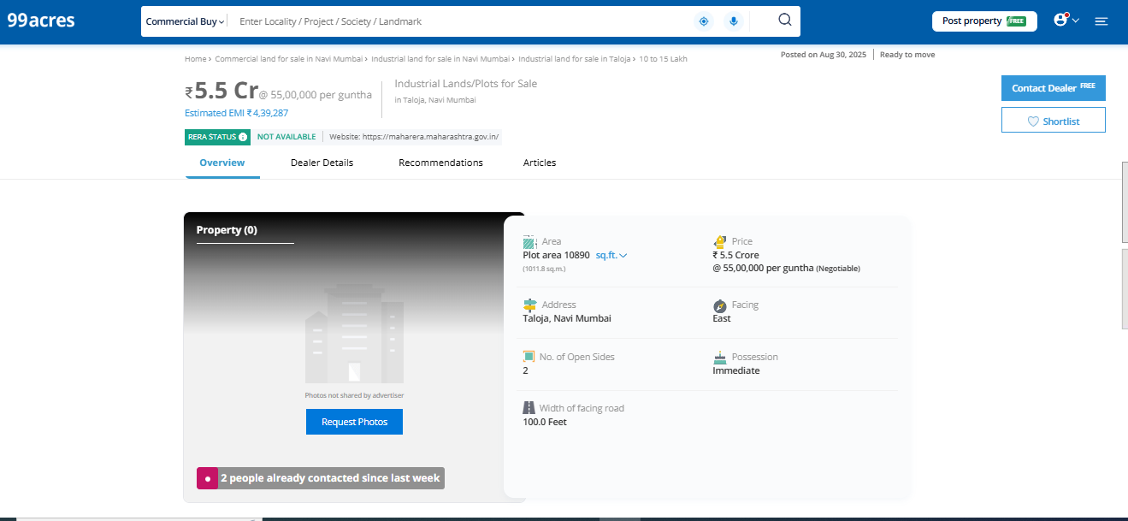

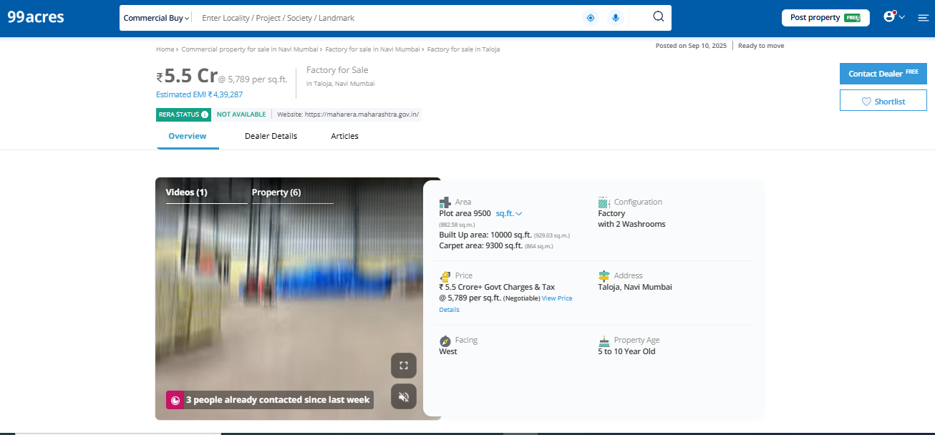

PRICE INDICATORS:
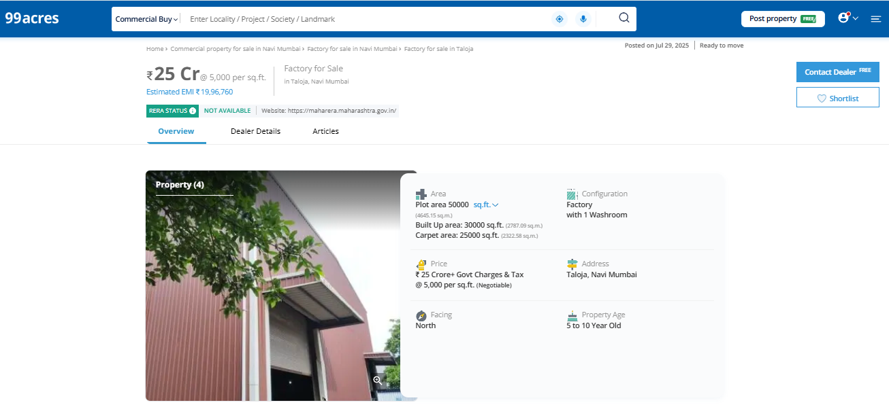
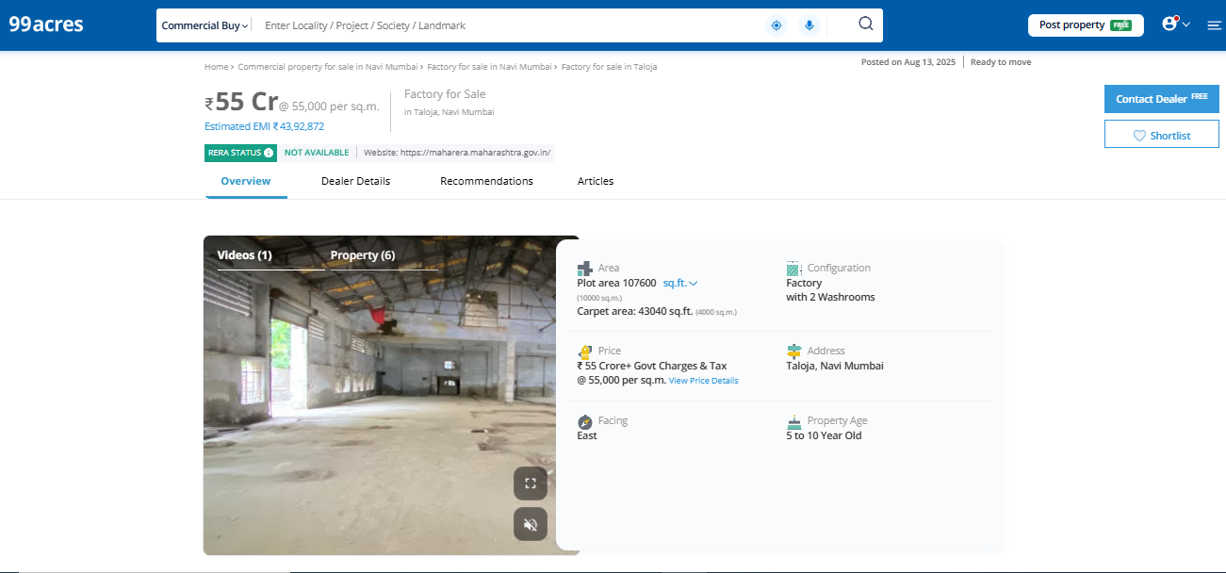

Photographs of the property

